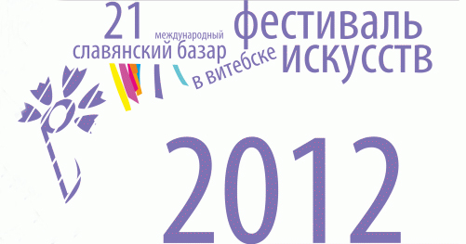


From 12 to 18 July 2012 the 21st International Festival of Arts Slavianski Bazaar in Vitebsk will traditionally bring together Slavonic and other performers on its stage.

The Festival will be launched with a solemn opening ceremony at the stage of the Summer Amphitheater.
I.Allegrova, Valeria, L.Leschenko, B.Moiseev, A.Rozenbaum, Buranovskie Babushki, State Academic Ensemble of the Folk Dance named after I.Moiseev, A.Lanskaya, Belarusian State Ensemble "Pesnyary", "Syabry" and many other performers will participate in the Grand Opening of the 21st Festival.
The evening will climax with the performances of Anne Veski, Kris Norman, Samantha Fox and Italian tenor Alessandro Safina.
Along with the shows staged by Belarusian and foreign performers the Slavianski Bazaar will give its audience a treat of theatricals, interesting films and exhibitions. "Theater Meetings" will take place at the National Academic Ya.Kolos Drama Theater and Vitebsk Concert Hall.
New movies will reach the silver screens of the Festival. The guests of the Festival will see four motion pictures of the filmmakers from Russia and Lithuania and a joint production of Belarus, Latvia and Estonia.
Days of National Culture will be organized during the Festival by Belarus, Russia, Ukraine and the Union State. Already traditional fair of folk crafts "The Town of Craftsmen" will also return to the streets of the Festival Vitebsk.
The program of the Festival also features the International Contest of Song Performers «Vitebsk-2012», with its jury headed by a composer, People's Artist of Russia M.Dunaevsky, and International Children’s Music Competition «Vitebsk-2012», where the jury will be led by the "patriarch" of the Georgian stage, composer and singer, D.Sepiashvili.

INTERESTING FACT

Twenty seven flags will fly in the sky of the Town on Dvina in the days of the 21st International Festival of Arts Slavianski Bazaar in Vitebsk, by the number of the countries presenting their arts at the Festival.
HISTORY

On 18 July 1992, the first ever festival of arts was staged in Vitebsk to give city residents and guests an idea of Slavonic song folklore.
In 1993, the Slavianski Bazaar in Vitebsk became a member of the International Federation of Festival Organizations (FIDOF), broadening the geography of its participants.
From 1995, the Slavianski Bazaar received the title of an International Festival of Arts.
In 1999, the number of festival events turned over 125.
In 2000 the Slavianski Bazaar hit a towering record by joining together on stage representatives of each and every Slavonic nation.
In 2011 Vitebsk hosted the 20th Anniversary International Festival of Arts Slavianski Bazaar in Vitebsk. Starting that year it became possible to book tickets for the Festival events on the Internet. On-line ticket sales are provided by the TecketPro company, operating in 17 countries of the World.

INTERESTING FACT

In 2012 the craftsmen folk will move to new premises within the territory of the Culture and History Complex "Vitebsk Golden Ring". "The Town of Craftsmen" will from now on be organized not only on its traditional places, but also in the "Posad of the Craftsmen".
Posad is a wooden building that imitates an old Slavonic settlement with fortified walls and towers. The Posad will offer entire palette of the folk crafts and hand-made items created by the craftsmen at fairs during the Slavianski Bazaar in Vitebsk.

More information on the Festival and the sales of tickets is available at the web-site of the Festival at www.festival.vitebsk.by.

Prepared by the Ministry of Foreign Affairs
of the Republic of Belarus
www.mfa.gov.by
info@mfa.gov.by

